Agenda- understanding the Log Level settings and configuring log level settings

Previously they were in Dev Studio but in 8.7 they are moved to the Admin Studio.

To create Log Categories navigate to the Admin Studio.

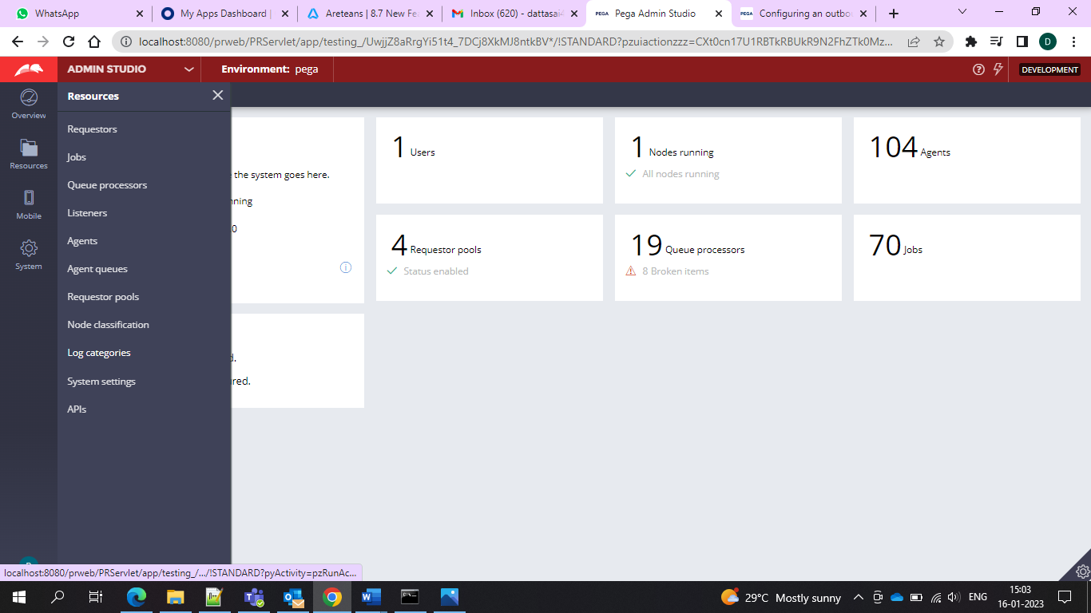

Click on the Log Categories

And then go for the 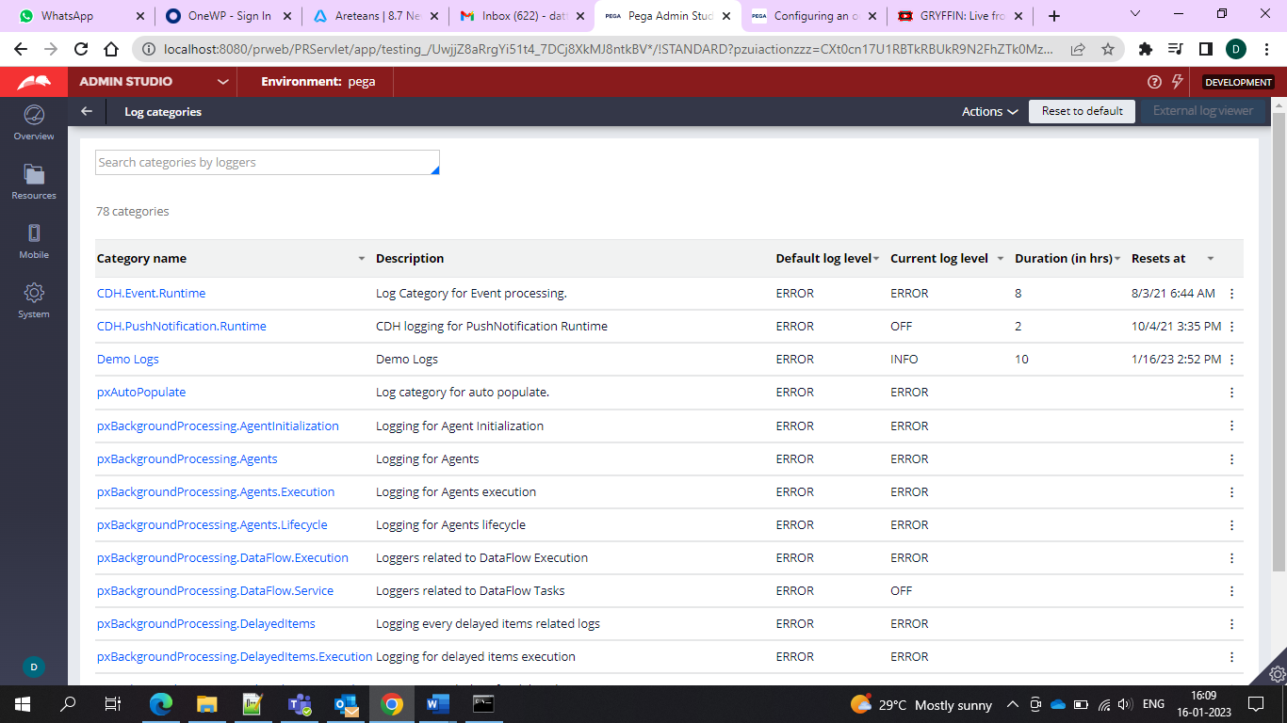

And now we can go for the creation of the log categories.

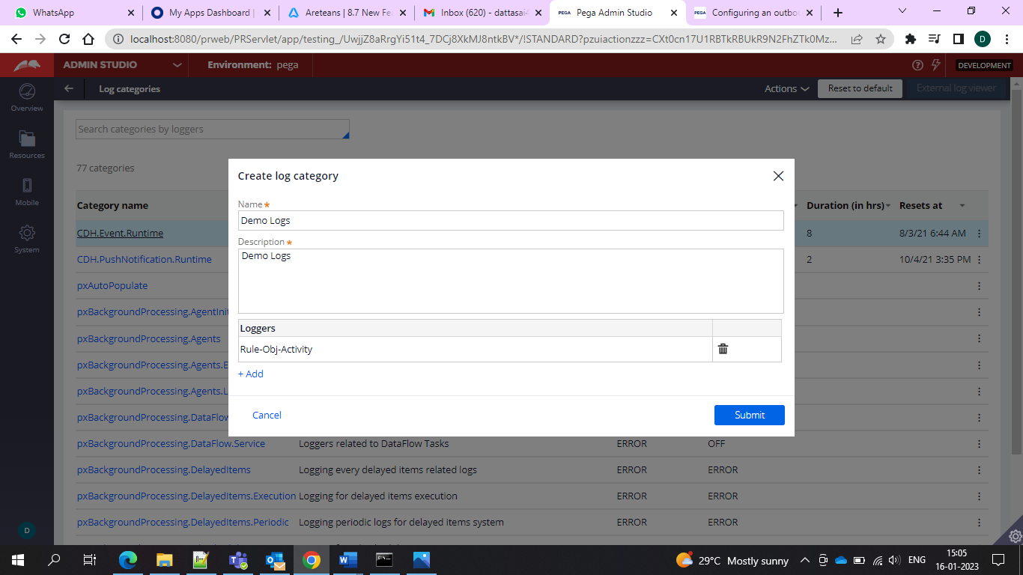

And now we have to go for the mentioning the log type and class and the operator and the rule for which this log category will apply.

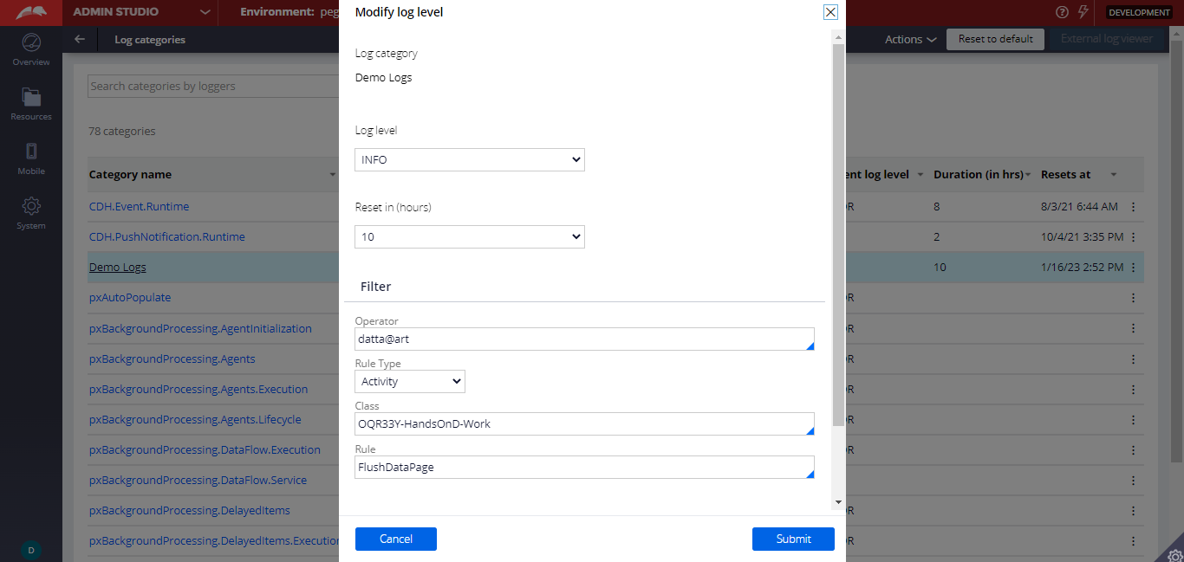

And point to be noted that only for the INFO an DEBUG we will have filters for others we wo’t have filter options to be specified.

And once we submit log category gets created and then we can check in the log files.

As shown below.

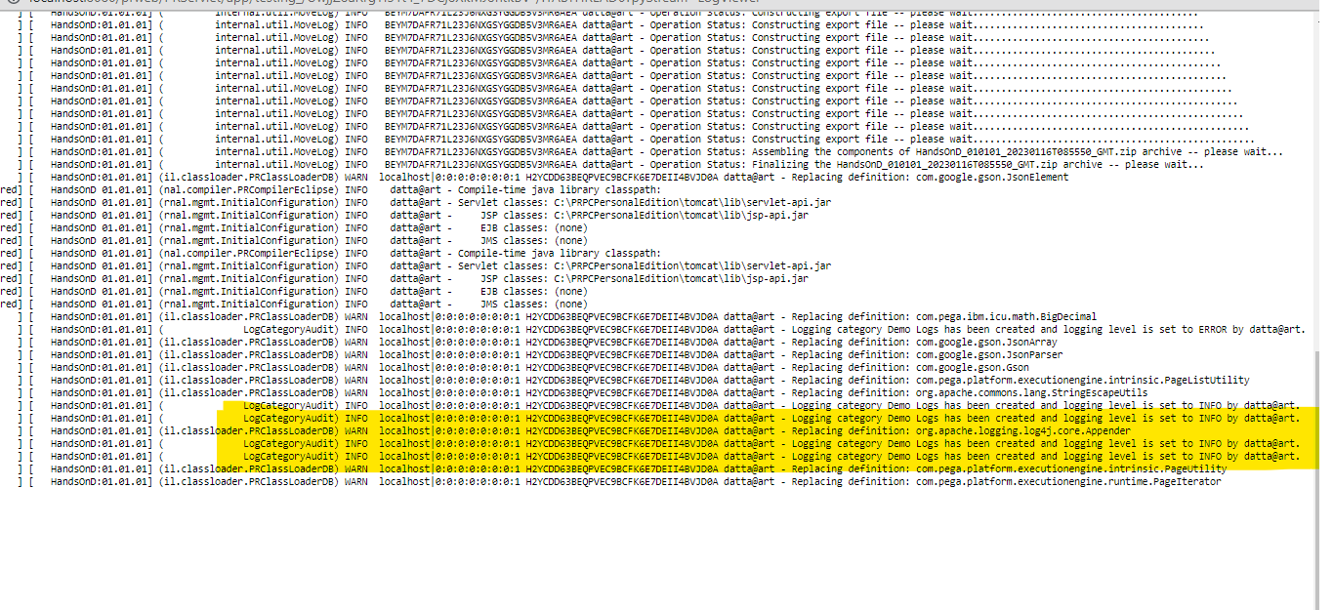

And also we can reflect record this log message with the help of the activity.

The activity would be like this

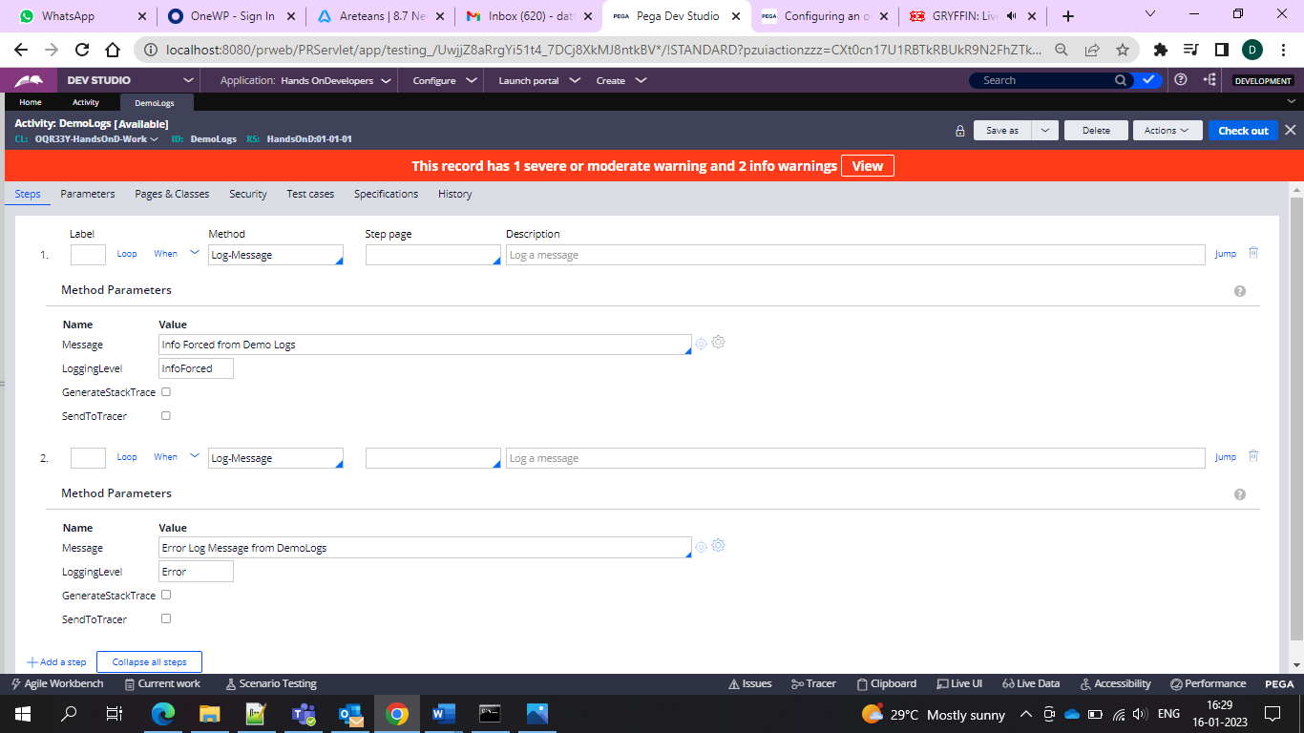

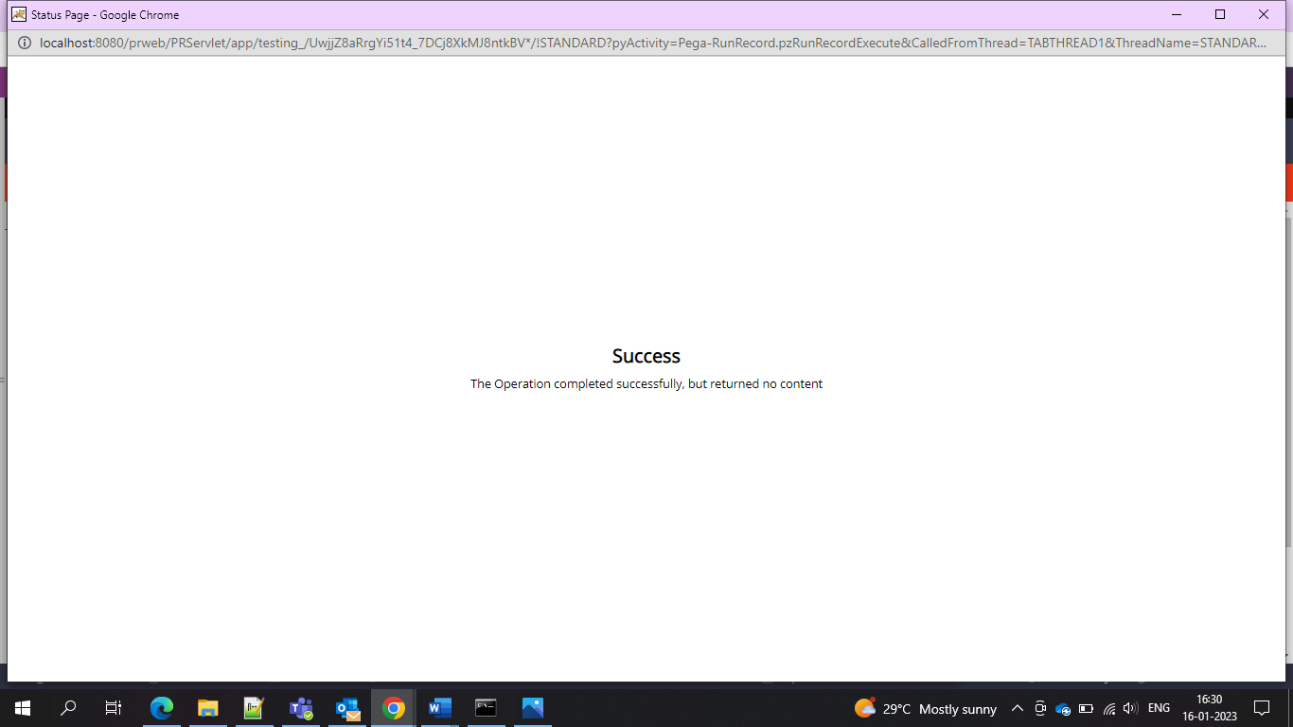

And when we run the activity the logs would be shown in log viewer.

